Minutes of the Parent Council of Woodlands School, Edinburgh held on Monday 29 January 2024, using Teams.

Participants: Carmen Black, Lynn Douglas, Sinead Reynolds, Christina Shand, Rhoda MacDougall, Lainey Gow

Apologies: None

 |  | Action By
1) | Minutes of Last PC meeting
 | The minutes were approved as true and complete record, with no comments and no objections.
2) | Correspondence
 | None
3) | Head Teacher Report
 | Please see Appendix 1 below for head teacher report.
4) | Treasurer Report
 | Please see Appendix 2 below for treasurer report.
5) | Sustainability Update
Lainey Gow gave an update on the sustainability efforts currently being undertaken at school.
- Lainey attends the sustainability meetings held by Edinburgh council.
- Each school has been asked to come up with a sustainability initiative.
- Woodlands are focusing on outdoor learning. Lainey met with the school Eco committee (Alex Martins, John Dyble, Helen Bell) to form a sustainability working group, and as a group they have agreed that they want to embed walking as part of the curriculum.
- All staff will take part in a school meeting on the subject. Alex Martins will send out an email to all to suggest walks local to school.
- This will build up to a whole-school sponsored walk on 11th June (provisional date). There will be easy, medium, and hard levels for the sponsored walk.
- The sustainability working group are seeking partnership with the parent council to help organise this – all agreed that we would participate. Lots of parent helpers will also be required to make this a success.
- The sponsored walk will hopefully raise funds for environmental charities – exact charities are still to be determined – learners may get involved in this decision.
- Further information to come.
6) | Christmas Fair feedback
 | No parents outside of the parent council attended the meeting, so we were unable to gather feedback as hoped. The committee members and head teacher did discuss some points that we will re-visit nearer the next fair.
7) | A.O.B
- Parent council to purchase an Easter egg for each learner.
- Prom date is still to be decided but will most likely take place in June.
- Curriculum update: base class model seems to be going well so far. Rhoda would like more parents to become involved in working group to discuss possible future updates. Please email school if interested.
- After February break, school hope to start inviting parents/carers of classes running the assembly, to the school assemblies.
8) | Dates of Future Meetings
 | Monday 25th March, 7:30pm on Teams

Appendix 1: Head Teacher Report

Head Teacher’s Report
Parent Council – Monday 29th January 2024

Staffing
- Our HE teacher Loren is now on mat leave so we no longer have HE on the curriculum at the moment. Our young people are making use of the HE space to do low level life skills tasks like making a sandwich, drinks, toast etc
- Alex Matthews was successful at interview for the mat leave cover teacher post. He has taken on General L Class which has freed up Leah Anderson to become our health and wellbeing teacher. Leah is working across the whole school doing a variety of sessions around health and wellbeing for all young people.
- We have two new PSAs in the school Jazza and Ana and they are supporting General L class. There is a further PSA post to be filled at Woodlands so we are hopeful that we fill this post from this round of interviews

Union Activity
- I have a meeting with the Director of Education on 2nd February to update about the concerns that Unison members had around aspects of the building, staffing and levels of violence
- Continue to have termly meetings with union representatives from school and local authority level regarding Woodlands

Staff Training
- Better Relationships, Better Learning, Better Behaviour - we had a session with our Educational Psychology team in November to discuss the concerns outlined to unison/EIS. The follow up session is this Thursday 1st February for all staff
- During the January in-service day staff were trained in the following:
- Child Smile – all young people who have signed up to the daily tooth brushing programme now have access to input in their daily routine
- Trauma informed practice – Keith Millar, HT at Gorgie Mills School, held a session on good supports and strategies working with young people who have experienced trauma
- 12 staff were trained in CALM to support young people who present with behaviours of concern

School Grounds and Play Areas
- Friends of Woodlands are working hard to raise money to develop our school grounds including a charity comedy night on 14th June 2024, venue to be confirmed shortly.
- Julie Kelly and team visited the trim trail playground last week to offer advice on next steps for choosing equipment for this area.
- A ground survey will take place this week which will be the first step in knowing what equipment we can potentially have in this area
- General O Class are in the process of creating a video about the space that can be shared online and with organisations who may donate money towards this project

Learning and Teaching and Quality Assurance
- A team from City of Edinburgh Council carried out a day of quality assurance visits to all classes at Woodlands and gave constructive feedback to staff. Strengths were staff relationships with our young people, team work, young people are happy and on the whole well engaged at the school
- There will be further quality assurance activity with observation of learning and teaching in all classes across the school after the February holiday
- As part of the ongoing curriculum review Rhoda will invite the core parent group to a meeting to discuss the next steps and information from this meeting will be shared with the school community

News!
- Loren, our Home Ecconomics teacher had a healthy and beautiful baby boy, both mum and baby are doing extremely well!
- From the February holidays onwards parents from the classes that are leading assembly will be invited to come into school to see the class showcase

Rhoda MacDougall
Headteacher

Appendix 2: Treasurer Report

Since the last meeting, funds have grown by £449 to £4,680. The biggest events contributing to that change were the Christmas fair and the costs of the Christmas gifts provided to learners at the school in December 2023.

Christmas Fair
The Christmas fair itself generated income (after costs) of £1,464, of which £426 was generated by the school stalls and has since been passed onto the school. Of the remaining £1,038 generated by WPC, the vast majority of that (£827) came from the Prize Draw with £211 being generated by the stalls on the day itself, having absorbed the cost of the invitations - £50 (see below).

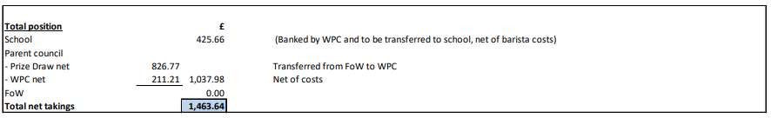

The various ins and outs related to the Christmas fair are noted below.

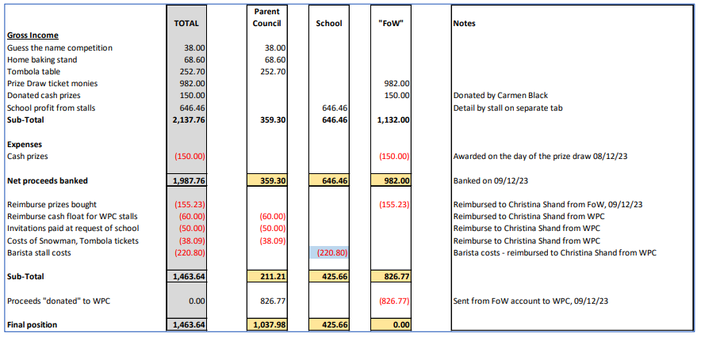

There is an argument that the cost of the invitations (£50) should have been netted off from the school costs rather than the parent council, ie only £376 should have been passed back to the school.

Christmas gifts / party costs
Following the Christmas fair, £590 was spent by WPC in relation to costs relating to Christmas gifts for learners / Christmas party.

Lottery licence
A new lottery licence is in place (cost, £20), and the licence lasts for the full calendar year (1st January 2024 – 31st December). This allows the WPC should they wish, to run prize draws in 2024 (under the guise of FoW).

Christina Shand,
29th January 2024

