Minutes of the Parent Council of Woodlands School AGM, Edinburgh held on Monday 25th November 2024, using Teams.

Participants:
- Carmen Black (Secretary)
- Christina Shand (Treasurer)
- Lynn Douglas (Chair)
- Sinead Reynolds (Vice Chair)
- Rhoda MacDougall (Headteacher)
- Gaynor Boe
- Alison May
- Emily Shaw
- Ceri Robertson
- Simba Doak
AGM

- Minutes from last AGM meeting
The minutes were approved as true and complete record, with no comments and no objections.

- Chairperson report
No updates – everything covered in headteacher report.

- Treasurer report
See full report in Appendix 1.

- Parent council committee elections
All current committee members stepped down – the following new members were elected:

- Chair = Gaynor Boe (proposed by Carmen Black, seconded by Sinead Reynolds)
- Vice Chair = Sinead Reynolds (proposed by Christina Shand, seconded by Simba Doak)
- Treasurer = Simba Doak (proposed by Gaynor Boe, seconded by Rhoda MacDougall)
- Secretary = Emily Shaw and Carol Pake (proposed by Christina Shand, seconded by Simba Doak)

Parent council meeting

- Headteacher update
See full update in Appendix 2.

- Holiday hub update
Update on this was given by Sinead.

- Edinburgh Children and Families committee met in September, attended by some parents.
- Council is proposing savings of £900,000 by reducing holiday hub provision.
- Elected councillors asked that council officers met parents for consultations.
- Holiday hub numbers are increasing over the years.
- Holiday hub provision has been in place for last 20 years – but council state there is no legal obligation to provide this.
- Holiday hub will run in February and Easter 2025 – what happens after that is uncertain.
- Parents report very poor communication from council.
- Five working groups sessions were set up with council and parents.
- Key issues are staffing, recruitment, venues, maintenance at schools during holiday periods (therefore meaning they cannot be used as venues), budget.
- Discussion around whether parents could pay more for provision.
- Most children attending holiday hub get 1:1 support.
- Consideration as to whether number of weeks offered could be reduced.
- Committee help special meeting end of November where deputations were received from parents to committee members, trying to get reassurance from elected councillors that they understand how critical the provision is for children, parents, and carers. See link: https://democracy.edinburgh.gov.uk/documents/b25503/Deputations%2028th-Nov-2024%2010.00%20Education%20Children%20and%20Families%20Committee.pdf?T=9
- Full committee report available at: https://democracy.edinburgh.gov.uk/documents/g7464/Public%20reports%20pack%2028th-Nov-2024%2010.00%20Education%20Children%20and%20Families%20Committee.pdf?T=10
- Full council meeting in February 2025 to confirm budget.

- Home/school communication

- Experience of parents/carers is variable, with regards to the information they receive about their child’s day at school.
- It seemed to start well, but has dwindled.
- A few parents have reported they receive very little information.
- Rhoda will send an email to staff to ask for examples of the kind of information that is being sent home.
- Parents/carers should contact Rhoda directly with specific concerns.

- Christmas fair

- Organisation is on track for fair.
- Number of volunteers to assist.
- Have enough raffle prizes – email will go out to ask for tombola donations.

Appendix 1 – Treasurer report

Woodlands Parent Council
Treasurer’s update – AGM - 25th November 2024

For the year 1st July 2023 to 30th June 2024
The year ended with a net inflow of £774 and funds available of £5,005.
Since the previous report was published in January 2024, there have only been a handful of transactions.
Comments | Expenditure | Income
March 2024  Annual easter egg gifts for students | £153
April 2024  Annual contribution from Edinburgh Council |  | £478
July 2024 *  Sponsored Walk funds raised by students for SSPCA |  | £1,558
August 2024 *  Donation to SSPCA in relation to sponsored walk | £1,558

* These items fell after the conclusion of the year end of 30th June 2024.

A recap of the financial year 2023/24.
We have now completed our 2023/24 financial year.
In summary, income at £2,311 was greater than our expenditure (£1,537) to the tune of £774.
The increase on income compared to last year (£2,311 vs £1,776) was driven by the inclusion of a raffle draw as part of the Christmas Fair
The fair itself made a net £1,464 from proceeds of £1,833 and associated costs of £364.
The proceeds themselves came from the parents’ stalls (£360), the staff / pupil stalls (£646) and the net income from the Christmas raffle (£827).
Other income of £487 came from Edinburgh Council with their usual contribution towards our running costs.
There were less outgoings than last year (£1,537 vs £2,827), the reduction being driven by a lower level of donations to Woodlands School than in the previous year. Offsetting this was greater costs attributable to Christmas gifts for students together with increased Christmas fair costs arising from Barista costs.
The only “Donation” to the school was the net funds from the Christmas fair tables, donated bac to the school after Barista costs,

Lottery licence
We have a licence in place for 2024, and the new licence for calendar year 2025 is in the process of being applied for.
As a reminder, small “on-the-day” type raffles (the type using cloakroom tickets as an example) do not require a licence. However, the type of raffle with tickets taken home and sold to family members as an example does require a licence.

Bank Account
No changes to report on. Access to the account itself and the ability to make payments is running fine. Administration rights also have finally moved across to the treasurer role.

Activities since the year end
There have been two transactions taking place within our bank account since the end of our financial year of 30th June and today’s date, both of which are documented on the first page.
These two transactions related to the sponsored walk undertaken by pupils and staff that took place immediately prior to the summer break, the proceeds of which have been sent on to SSPCA.

Christina Shand,

24th November 2024
Woodlands Parent Council
2024 Year End accounts (as at 30th June 2024)

Income Statement  Income  Christmas Fair |  | 30 June 2024 |  | 30 June 2023
Income Statement  Income  Christmas Fair |  | 1,833 |  | 1,223
Edinburgh Council (PC expenses) |  | 478 | 478
Bank redress following complaint |  | 0 | 75
Total Income |  | 2,311 |  |  | 1,776
Expenditure  Christmas items (cost reimburse) |  | 590 | 106
Christmas Fair costs |  | 369 | 164
Donations to Woodlands School | (note) | 426 | 2,082
Parents "well-being" boxes |  | 0 | 0
Lottery Licence |  | 0 | 40
Easter Eggs |  | 153 | 149
Leaving gift - Angelina |  | 0 | 100
Total Expenditure  Net (Expense)/Income |  | (1,537)  774 |  |  | (2,827)
Total Expenditure  Net (Expense)/Income |  | (1,537)  774 |  |  | (1,051)
Reconciliation of Income Statement / Net Assets  Assets at start of year |  | 4,231 |  |  | 5,282
Net (Expense) / Income  Net Assets as at date of this report  Net Assets represented by  Bank account  Net Assets available |  | 774  5  ,005  5,005  5  ,005 |  |  | (1,051)
 |  | 774  5  ,005  5,005  5  ,005 |  |  | 4,231
 |  | 774  5  ,005  5,005  5  ,005 |  |  | 4,231
 |  | 774  5  ,005  5,005  5  ,005 |  |  | 4,231
Note  Donations to Woodlands School  Woodlands school, Christmas Fair tables, net | of Barista | costs 426
Memorial Bench |  |  |  |  | 750
Foodbank |  |  |  |  | 300
Water Trays |  |  |  |  | 258
Share of decommissioning costs - Trim Trail |  | 426 |  |  | 774
Share of decommissioning costs - Trim Trail |  | 426 |  |  | 2,082

Appendix 2 – Headteacher report

Head Teacher’s Report
Parent Council
Monday 25th November 2024

Staffing
- Our PT Justine Fialka and Class Teacher Leah Anderson both left for maternity leave Friday 1st November. Andrew Jack is now teacher in Wolves Class and Stephen Mells Acting PT in Deer class, both in post until June 2025
- 4 PSA staff left in October, 3 were due to the salary not being enough. Ongoing PSA staffing issues in school and this is very challenging to manage consistency across the school. Using agency staff and where necessary using supply teachers to support/team teach in the absence of PSA staff
- Loren Alexander returned from maternity leave on 7th November as our Home Economics teacher

New Class Names
- Our young people voted for class names to be Scottish animals – class names are as follows:

Hares Alex Matthews
Beavers Helen Bell
Foxes Jude Moyes (Principal Teacher)
Puffins Eoghann Douglas
Squirrels Bethany McFarlane
Otters Lainey Gow (Principal Teacher)
Ospreys John Dyble
Eagles Julie McGarvey
Wolves Andrew Jack
Wildcats Susie Murphy
Deer Stephen Mells (Acting Principal Teacher)

School Grounds
Additional basket swing now installed in quiet playground and new climbing frame installed in trim trail playground.

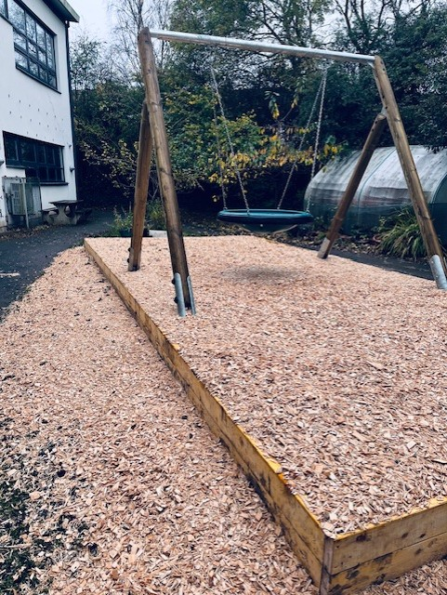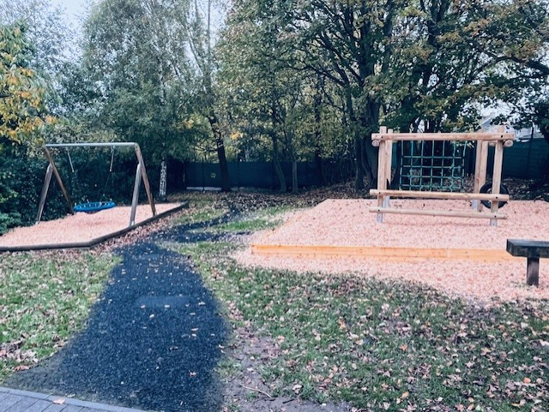

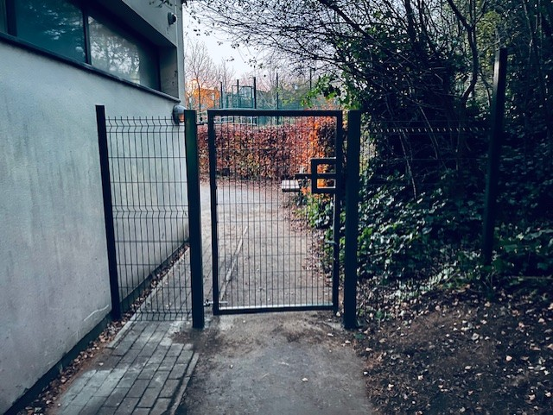
- Gate to separate south playground from quiet playground installed 9th November
- Consultation underway for further development of school grounds to ensure greater variety and inclusivity for all young people
- Friends of Woodlands meeting on 29th November 10am

Staff Training
- CALM theory training – now well underway and staff will be accredited in January
- Signalong training – sessions for staff and parents in the diary for Thursday 28th November and will hopefully be well attended
- January in-service training for staff will focus on Signalong, aided language boards and a session about our school vision values and aims for Woodlands School

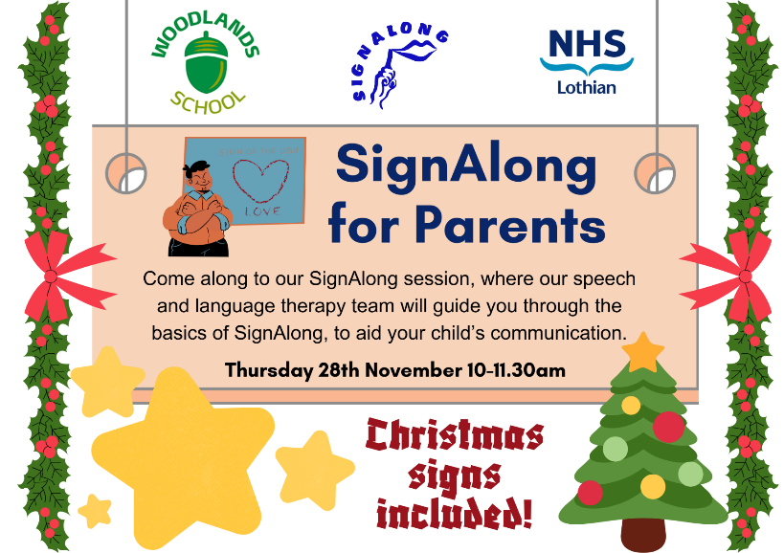

Parental Involvement
- Acorn Café – we have been lucky to have regular parent helpers every Friday at the café and this is working really well and is lots of fun for everyone
- Our school assemblies are well attended by the class who does the spotlight each week and we have had so much positive feedback from parents who have been able to attend
- We have some parent helpers for our upcoming visit to the panto on 5th Dec

Parent Consultations
- Offered a blend in person, online or phone call consultations
- All consultations took place in classrooms and subject specialist rooms and the following colleagues supported in the dining hall as a ‘drop-in’ for parents

Gaynor Boe Woodlands Parent Council Chairperson
Ariana De Matas Educational Psychologist
Heather Robertson Speech and Language Therapy
Sarah Cunningham Speech and Language Therapy
Vicky McDermott CAMHS
Kim Haggart School Kitchen
Ruth Addo Careers Advisor Skills Development Scotland
Rebecca Adams Developing the Young Workforce
Jayne Ely-Black FAIR (Family Advice & Information Resource)

School Building and Adaptions
- We have relocated the DHT office to create a break out space for our young people upstairs. This space will be used for a quiet space, regulation zone, nurture. This will be a work in progress over the coming months
- We have had a survey of our current toilet facilities on both floors of the school and work is being carried out by surveyors to improve the current spaces and also to extend the amount of toilets we have for our learners

Holiday Hub
- Our school will not be used for the February holiday hub due to major works taking place to upgrade our school toilets
Christmas Fair Friday 13th December
Otters - Knitted crafts, wreaths, clay ornaments – reception area
Squirrels - Salt dough decorations - outside classroom
Puffins - Salt dough decorations - outside classroom
Foxes - Santa sweetie cones - outside classroom
Beavers - Chocolate reindeers and karaoke - outside music room
Hares - Painted Christmas trees - outside classroom
Deer - Christmas jewellery and Christmas cards - in the hall
Wolves - Christmas goodie bags - in the hall
Ospreys - Artisanal Christmas cards - in the hall (beside the café)
Eagles - Tealight holders and bookmarks - in the hall
Mrs Alexander - Christmas biscuits - in the hall
Wildcats - Karaoke in the Music Room

