Minutes of the Parent Council of Woodlands School Edinburgh held on 17.3.25 in School

Participants
- Gaynor Boe (Chair)
- Sinead Reynolds (Vice Chair)
- Rhoda MacDougall (Head Teacher)
- Carol Pake (Joint Secretary)
- Emily Johnston (Joint Secretary)
- Simba Doka (Treasurer) - online on Teams
- Caroline Reid
- Ceri Robertson
- Andrew Jack (Class Teacher) - staff presentation
- Pamela Dent (PSA) - staff presentation
- Donna Leitch (PSA) - staff presentation
No apologies were received

1.Minutes from previous PC Meeting
These were approved as a true and complete record, with no comments or objections.
2.Headteacher’s report
See Appendix I
Rhoda also highlighted the following with regards to the School website
- There will be regular updates on the website with a PT taking charge
- The School newsletter will be put onto the first page
Parent Council names will be updated to the new names. Rhoda will contact Alex re this
The School will be used as a Holiday Hub over the Easter holidays
S1 Parents will be contacted to ask if they want to be added to the Whatsapp group. It was agreed to keep one main Whatsapp group (no separate one for S1 parents).
For the S1 transition evening on 19th June a classroom will be assigned to S1 parents who wish to come along and meet with Parent Council members. This will allow easier communication and sharing of information for new parents.
It was agreed that there will be no Easter eggs this year but the PC will donate funds for class parties. Simba will ascertain what has been spent previously to match this amount.
3. Andrew Jack – Staff presentation
Andrew is a Class Teacher in the Senior phase of the School and is in charge of the Pupil Council.
Andrew gave a presentation on The Pupil Council which is below as Appendix II
4. Treasurer’s report
Nothing to report on the accounts. It was asked what the balance of the account is and Simba will share a copy of the last statement with the PC.
It was agreed that the PC will make a donation to the cost of Live Music Now who are providing sessions to various classes.
5. Pamela Dent – Staff presentation
Pam has been working with Ceri Robertson (parent) to plan and organise a parent & staff event on Friday 5th September at 7pm at Slateford Bowling club, no children at this event. The evening will consist of a quiz, “bottle toss”, disco, auction. They are looking for prizes and have suggested a spa treatment, manicure, a signed football. They have already paid £50 to the venue and have asked if the Parent Council can give funds for this. They have sourced a DJ and his cost will be £180. The suggested price for tickets will be between £5 and £7.
Parent Council are always looking for prizes for the Christmas raffle and it was said that we need to be careful not to duplicate prizes or ask the same people.
6. Donna Leitch – Staff presentation
Donna is currently organising the annual Prom for the school leavers. This will be held in Slateford Bowling Club on Friday 6th June and 4th, 5th and 6th year pupils will be invited to attend. Each pupil must attend with a responsible adult; 4th and 5th year pupils can bring one adult and 6th year pupils can bring 2 adults. Donna usually has monies in a fund and continues to fund raise year-round for this event, but funds are now very low and she has asked the Parent Council if they could donate £300. The PC have agreed to this.
7. Special Schools City Wide Meeting
Incontinent products – A survey was carried out and results collated and passed to NHS colleagues. A meeting will be held with Bladder and Bowel Team lead (Sarah Phelan), Ontex and CEC (David Fox, HT at St Crispins).
Transport – Concerns have been raised by a number of PCs, specifically in terms of changes of provision, delay & timescales in putting in arrangements and lack of communication. One parent had support from her other child’s mainstream school in order to make the transport arrangements work for her. Lynne Binne would like to provide positive feedback to the said mainstream school. She will also invite Frank Henerson (Transport) to attend the next meeting.
Holiday Hubs – The budget has been maintained and a further £100K has been allocated to support key officer posts. Allocations have been reduced from 4 weeks to 3 weeks per annum, parents noted their concern. A paper will be presented to ECFC on 25th March.
Special school estates review – 3 schools are at the end of their life and a decision will need to be made re the option for replacement moving forward. Scoping is currently taking place re the development of and inclusive learning estates strategy and this will be presented to ECFC in June. It was agreed that communication with parents is important to reduce anxiety and Lynne Binnie stressed that no changes will take place without consultation and agreement at ECFC. Jeff Hume (project manager) will be invited to the next meeting.
Breakfast & After School Clubs – A parent raised the possibility looking at this in the context of SDS/respite. Midlothian schools & St Crispins currently have this and Lynne will explore this further with them. It was noted that transport is cited as a barrier to this provision being put in place.
Braidburn school: centre of excellence for deaf children – Lynne stated that this is the intention but it cannot be progressed until the conclusion of the inclusion review. She suggested that this is discussed at school level in the next term.
Oaklands – Parent concerned re the changing profile of needs in the school. Lynne stated that this needs to be discussed at school level with the HT & PC.
Next meeting – 11th June
8. New parent handbook
It was fed back that details of the PC and Friends of Woodlands need to be added.
9. AOCB
Rhoda had a meeting with Jackie Reid (Executive Director) and Jenny Hutchison (HT Currie High School). Woodlands will have access to the gym and the pool. There are also sensory spaces in the new school which will be welcomed. Parent Council will have a visit to the new school when it opens after the summer.
Outdoor Education is now to become part of the regular classes with the base teachers
Feedback from attending the meeting online – it worked well except that Simba couldn’t see the presentation. Rhoda will share this in future.
10. Date and time of next meeting
To follow on from FOW meeting on Monday 2nd June. FOW meeting at 10am and PC meeting at 11am.

Appendix I HT report
Head Teacher’s Report
Staffing
- We have recruited a temporary Art teacher Michelle Cleasby provisional start date 24th March
- We have now been informed that schools can advertise for school specific PSAs which is great news for us. Interviews for Woodlands School 20th March

School Grounds
- Still waiting for the adaptions and improvements to 4 toilet areas in the school to be confirmed, Jackie Reid our Head of Education is very active in pushing this forward for us
- Our Health and Wellbeing working group have worked on a survey of additional equipment that could be added and will be shared at Friends of Woodlands meeting on 17th March

School Updates
- Fit for girls event Stirling 10th March
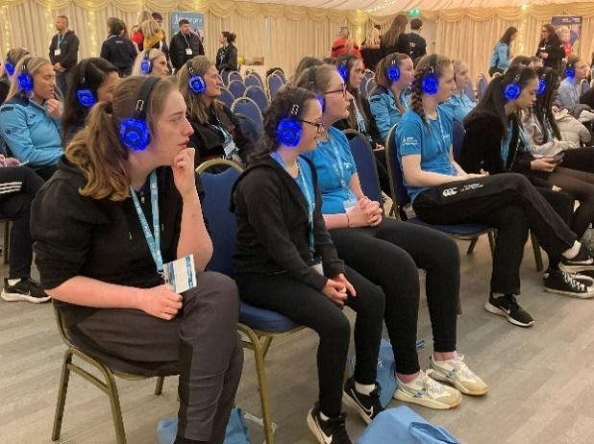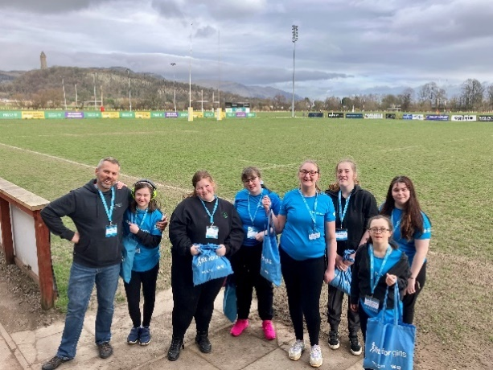
Woodlands was the only Special School in Scotland attending this event and Scottish Disability Sports would like to do an article on our attendance!

Timetable for Session 2025-25
- Outdoor Education – we will be looking for our base class teachers to be encompassing outdoor learning into the class curriculum and will be incorporating another specialist area into the timetable
- I am meeting with Jenny Hutchison, HT at Currie High, and Jackie Reid our Director to discuss use of the pool, gym and sensory spaces at Currie so that we have maximum use of all of these spaces for our young people

Parent Workshop
- Signalong training – The second session was held on the 6th March and 3 families were represented. The session was online to try to attract more parents and carers to attend the session. Looking to do joint training with another special school(s) to maximise SaLT time for these sessions. Would welcome ideas on encouraging parents to attend sessions.
S1 Parent Event 6th March
- Very well attended with 12/16 families represented.
- Parents and families were in groups to have a tour of the school with drop ins to classes with specific info on communication, behaviour approaches, transport and more
- Feel the event went well but improvements for next year will be in place, including a designated space for parents to meet Parent Council
- Next event for S1 parents in June will go into more indepth information about transport, lunches, uniform ordering

Parent Consultations
- 20th March consults – SaLT, CAMHs, Ruth Addo (Careers Advisor) to attend for drop in consults in the main hall

Holiday Hub
- We were informed Woodlands would be used for holiday hub at very short notice before the Feb break
- Preparation for the hub takes time to remove items and get spaces ready so we need greater warning and allocated spaces need to be adhered to by the hub staff

Supported Self Evaluation May 2025
- MWill be developing questionnaires to go out to pupils, staff, parent and partners to ensure everyone is engaged in evaluating our progress and where we need to head to next to ensure we continue to improve our work at Woodlands. This will help inform our school improvement priorities for session 2025-26

Staff presentations:
- Pupil Council and Rights Respecting School - Andrew Jack – Class Teacher
- Pam Dent – Staff/Parent event 5th September
- Donna Leitch – S6 Prom
Appendix II – Andrew Jack presentation


