Minutes of the Parent Council of Woodlands Schoo Edinburgh held on 02/06/2025 in school.
Participants
- Gaynor Boe ( Chair)
- Sinead Reynolds (Vice Chair)
- Rhoda McDougall (Head Teacher)
- Carol Pake ( Joint Secretary)
- Emily Johnston (Joint Secretary)
- Simba Doka (Treasurer)
No apologies were received.
- Minutes from previous PC meeting
These were approved as a true and complete record, with no comments or objections.

- Head Teacher Report ( See Appendix I)
Overview of inspection report is that Woodlands school is settled, conducive to learning with pupils happy and confident.
School is working hard to further develop all areas highlighted by the report.
Staffing update – PSAs will now be known as Pupil Support workers.

- Future chef
Loren ,Home Economics teacher, and Ryan (S6 pupil) came to share a presentation about taking part in Future Chef, an ASN cooking competition, on May 13th. Ryan and Sophia were finalists in the senior and junior competitions respectively with Ryan baking a fruit tart and Sophia making cupcakes. It was an amazing experience for both students. Thank you to Loren for sharing Parent Council found it very inspiring.

- School vision, values and aims
These need adapting and updating to be relevant for the pupils and represent where Woodlands is currently. Necessary feedback needed from the parents so reminders being sent via email, text and WhatsApp groups to encourage parents to complete the form. Responses in by June 13th.

- Home/School communication sheets

Next session our 5 specialist teachers will compile a weekly sway of photos and updates about what our young people have been doing in class each week. This will be in addition to the home school diaries. Parents have fed back that they would like more detail in the home school communication

- Currie High school update

Jenny Hutchison (Headteacher at Currie High School) came to share photos of the new high school and her vision of reigniting a closer partnership between Woodlands and Currie post Covid. Jenny is keen to work together to build a community and create a culture of inclusion and universal belonging. The hope is that there will be opportunity for Woodland pupils to use the spaces as well as get involved with Health and food, Exercise and fitness, dance, swimming pool, woodwork and music.

Woodland pupils will be given a tour of the new building either end of this term or beginning of next term. Early September there will be opportunities for parent tours.

- Music update

Raul, music teacher, updated the parent council on the ongoing fantastic projects happening in music at Woodlands:
- The pupils have benefited from Drake Music running sessions for 8 weeks with 4 classes using technology and mini keyboards.
- Live music from both a harpist and a clarinet quartet which the children found very inspiring and enjoyable.
- The Children’s festival – as part of this there were trips for the children to attend 2 shows
- New Project Edinburgh 900 – there will be a performance of 1400 pupils from different schools in the Usher Hall and the Woodlands choir has been invited to take part and will combine singing and signalong to participate in this event.

Many thanks to Raul for sharing all the wonderful initiatives that are being done at Woodlands involving music and the pupils.

- Funding request for Dance Troupe and Choir t-shirts

The PC agreed to fund the t- shirts. It was also agreed that Pam should be refunded for the deposit paid for the upcoming parent/ staff event .

- Treasure’s report see Appendix II
Simba reported that there had been limited activity on the account with just two outgoings: Deposit to secure venue for parent staff social and a contribution to LIVE music Scotland..

- Woodlands parent WhatsApp group

The plan is to expand the WhatsApp group to help with parent communication. There will be a PC space on the Woodlands website and on the school’s newsletter parent zone to advertise the WhatsApp group.

- New parent event in June

Gaynor and Sinead will be present to represent the PC and Friends of Woodlands

- Sponsored walk

Gaynor and Carol will man the stall to provide refreshments

- Next meeting

This will be held on Monday 1st September at 11am

Appendix I

Head Teacher’s Report
Parent Council
Monday 2nd June 2025

Inspection Follow Through Visit May 2025
- School is settled, young people are happy and confident attending Woodlands
- Parents and partners feel there is more open communication with the school and there is a collegiate approach to supporting our young people
- The Visual Supports Project has been very successful across the school and already making very good impact on learners
- Vision, Values and Aims - consultation out to all but so far only 2 responses from parents
- Further work on IEP target setting, Planning and teaching and learning across the school

Staffing Updates
- PSA staff have now been renamed as Pupil Support Workers (PSW) but remain on the same grade
- Leah Anderson (Class Teacher) and Justine Fialka (Principal Teacher) popped in for a visit with baby Nora and baby Freya!
- Andrew Jack is now a permanent member of the teaching staff. Stephen Mells, Acting PT has had his contract extended to end of Oct 2025
- Injury for a member of staff – RIDDOR and subsequent management of how incidents are managed
- Our FM is currently signed off work, so we currently have a reduced FM service at Woodlands

School Building and Grounds
- Meeting on 9th June – work for toilet adaptions is still outstanding
- The decking at school entrance – has been reported but work still outstanding

School Updates
- School Choir and School Dance Troupe - Raul
- Live Music Now Scotland – Raul
- Future Chef Competition - Loren
- Fundraising – Ceri
- Parent Information booklet updated with thanks to PC for amendments/additions

Parent Workshops 2025-2026
- Parent workshops on Signalong have been very poorly attended but feel this is something we still need to offer
- Guardianship sessions to support parents with understanding on what to do
- Any other ideas for supporting parents?

S1 Transition to Woodlands
- Event on 6th March and second parent evening on 19th June from 4.30
- Senior leaders have attended all reviews to gather info which has been shared with staff as appropriate
- Parents and families were in groups to have a tour of the school with drop ins to classes with specific info on communication, behaviour approaches, transport and more
- Feel the event went well but improvements for next year will be in place, including a designated space for parents to meet Parent Council
- Next event for S1 parents in June will go into more in-depth information about transport, lunches, uniform ordering

Parent Consultations 2025-26
- Contact The Yard to ensure we don’t clash with dates next year!
Holiday Hub
- Hope to have building works done so at this point unlikely we will be used for holiday hub

Outdoor Learning and Wider Opportunities
- To ensure there is equity across the school base class teachers will have access to the Dawson’s Trust fund - £5,000. In this way every young person will access some kind of outdoor sports or events
- We have been making more connections to access a variety of drama and arts events that are suitable for our more complex learners. Here are Beavers enjoying "When the World Turns" - a living, breathing, sensory adventure!

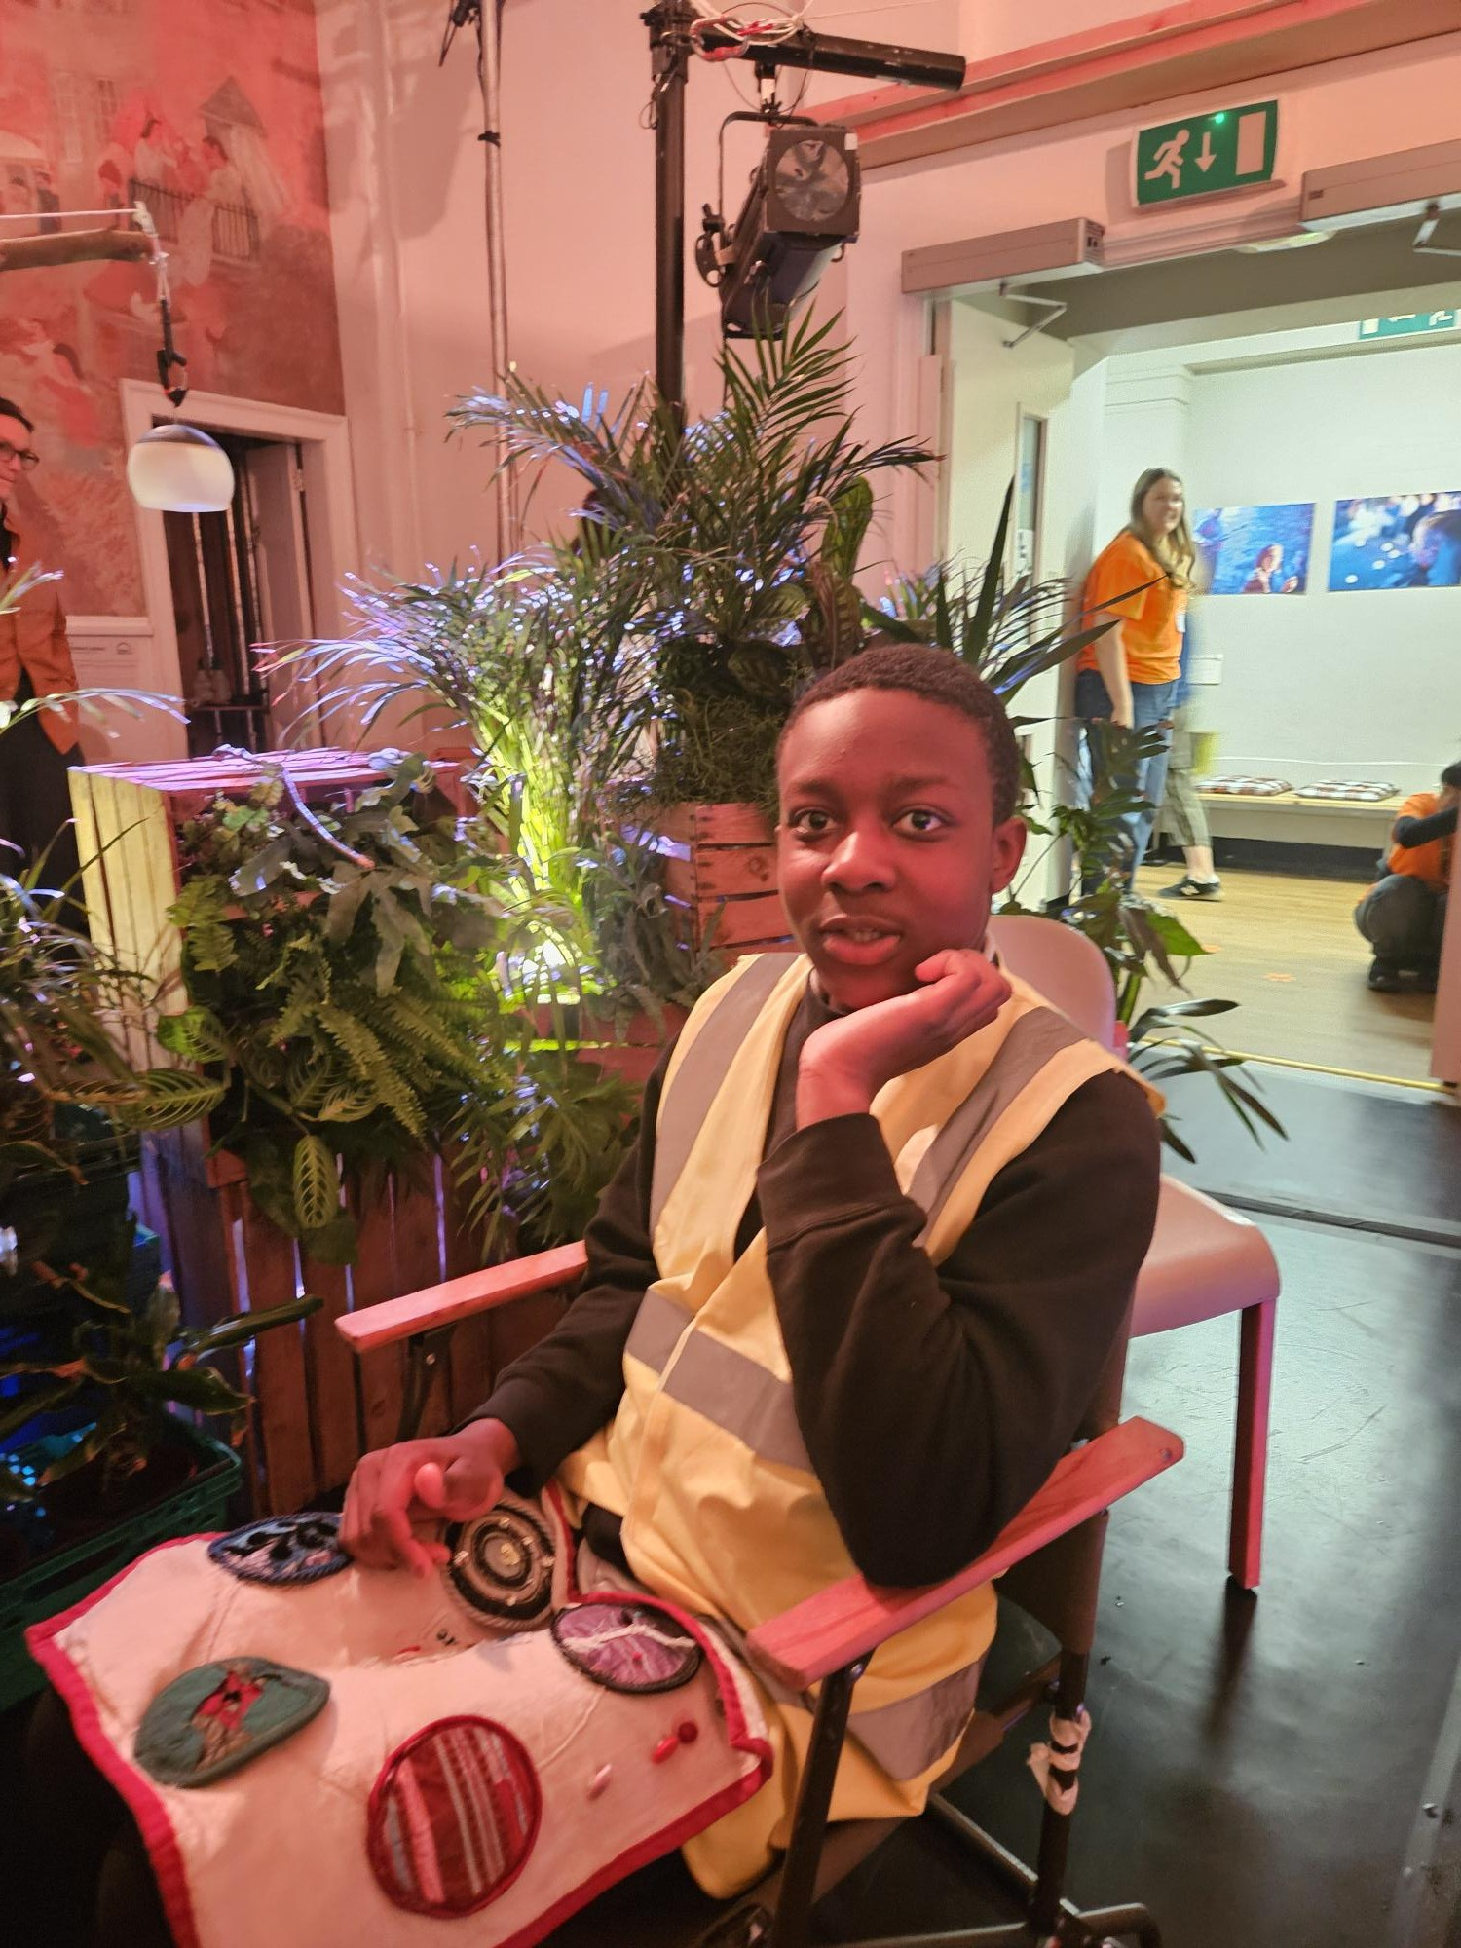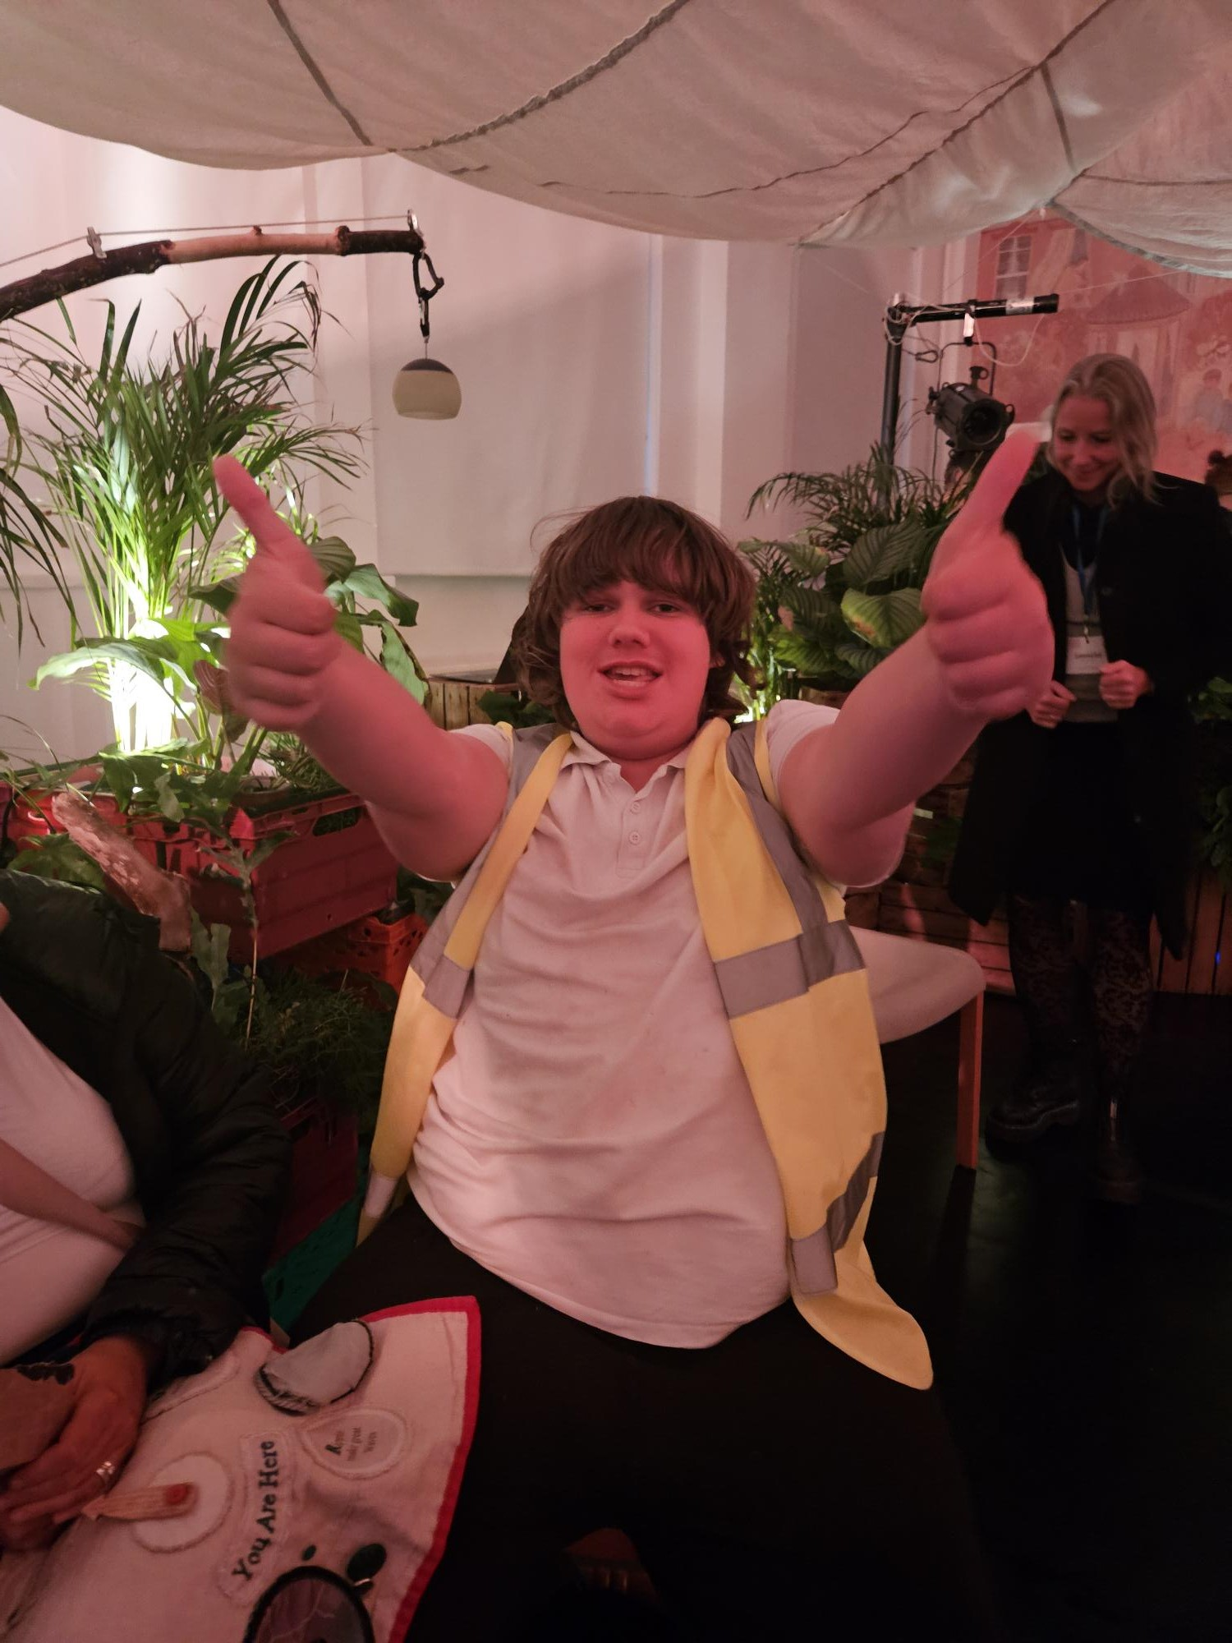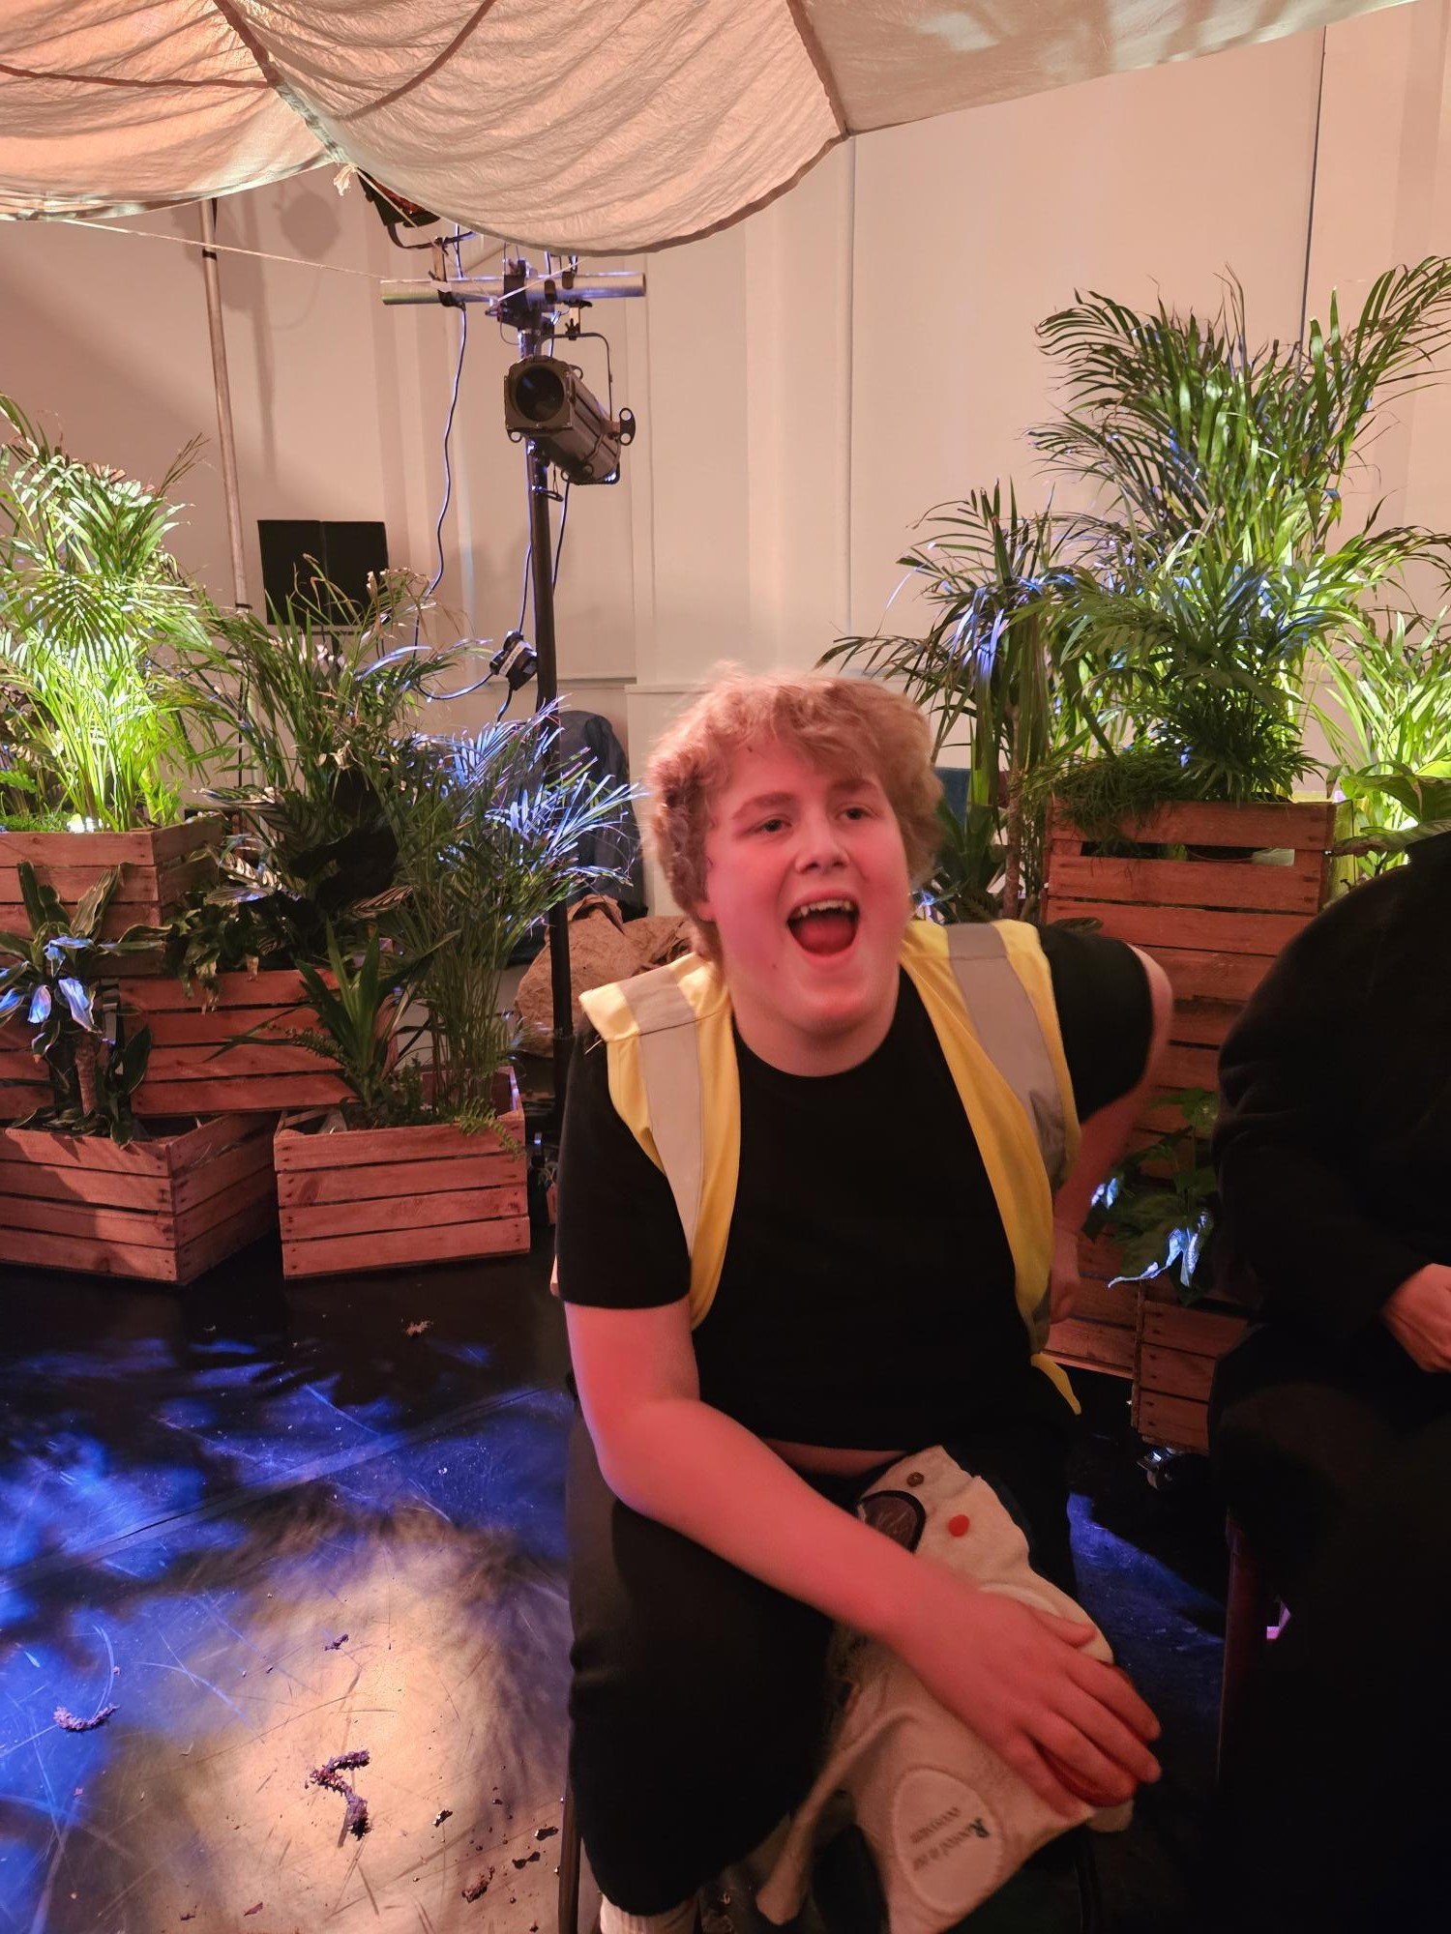
Acrorn Cafe Thank you!
- A huge thank you to Alison and Greig May who have been amazing volunteers in the Acorn Cafe this session! I don't know what we will do without you both next session!

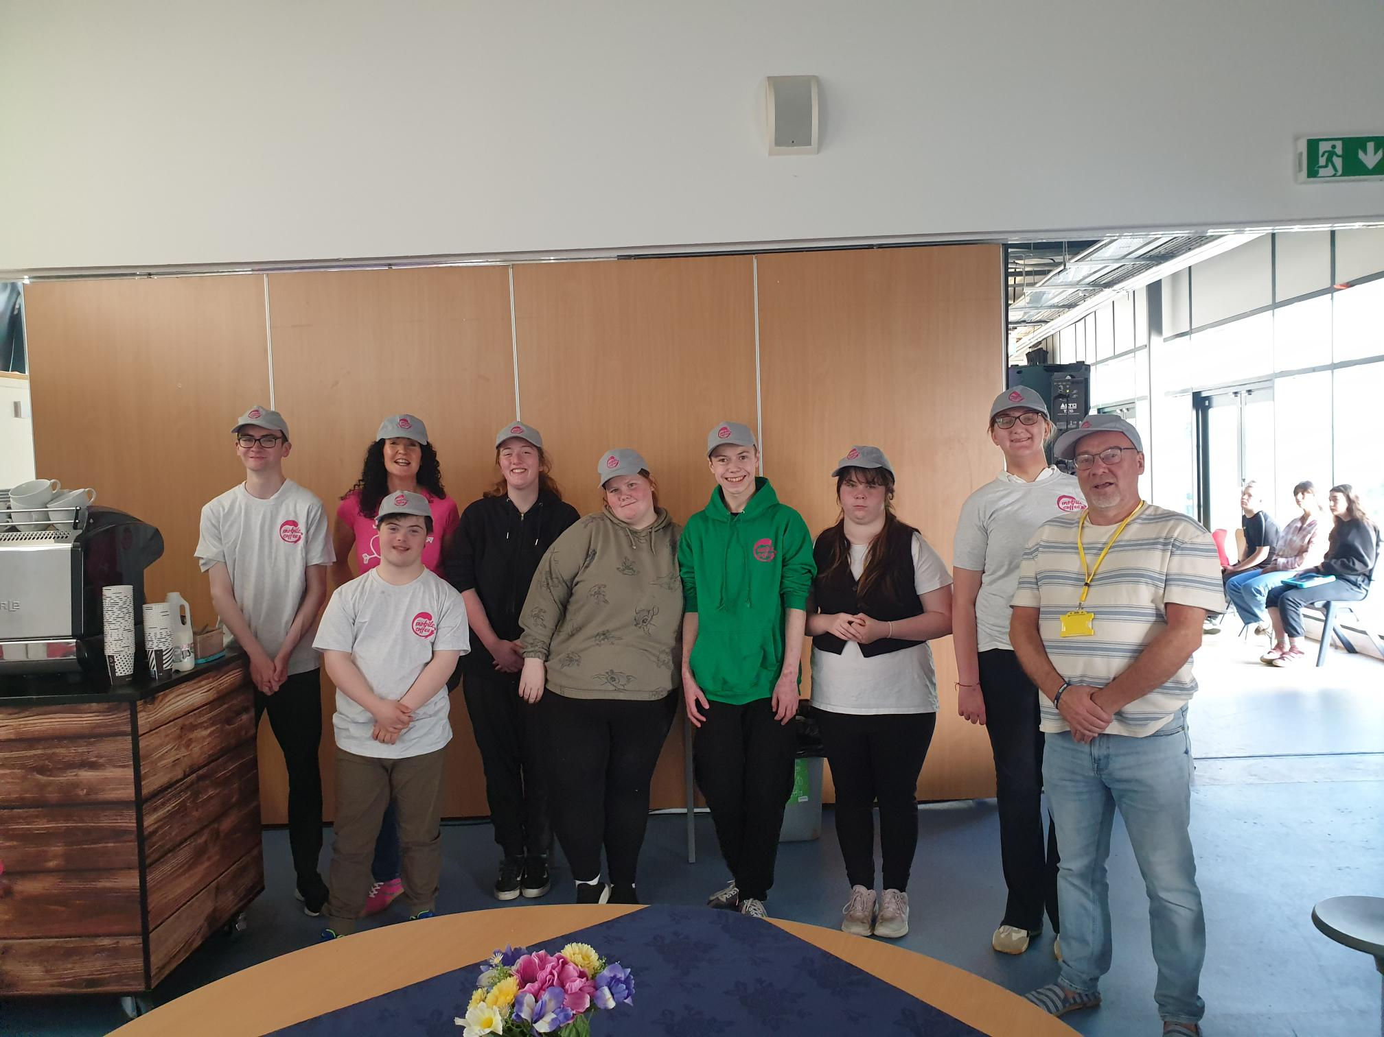

Appendix II

Treasurer report
