Dear Parents, Carers, December 2025

I hope you are all well and managing to avoid the many winter bugs going around at the moment. I also hope you enjoy this edition of The Sway, which showcases the many lovely stories and achievements from across the term. Please find our latest updates below.

Staffing Updates:
As you know, Mr K, our PE teacher, will be officially leaving Woodlands at the end of this term. Mr K has worked at Woodlands for many years and will now be studying full-time at Stirling University to train as an Educational Psychologist. Perhaps we will see him return to the City of Edinburgh in a new role in the future.

We would like to thank Mr K for his dedication and commitment to our young people over the years and wish him every success in his studies.

In the new year, we will be welcoming a new teacher to Woodlands. His name is Ross Silver, and we look forward to him joining our school community.

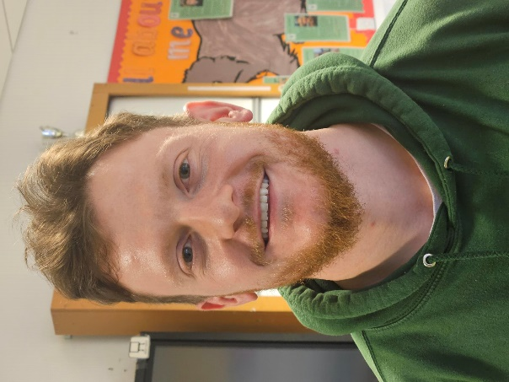
Ross Silver

Youth Music Initiative (YMI)
We enjoyed a wonderful carol concert on Thursday morning, supported by the Youth Music Initiative. Our school choir sang alongside the YMI musicians, creating a lovely festive atmosphere for everyone. Many thanks to Raul for organising this fantastic musical experience for our learners and staff.

Parent Coffee Mornings
We have been holding monthly parent coffee mornings since September, and it is encouraging to see attendance continuing to grow. We aim to vary dates and times to allow as many parents and carers as possible to attend. The next planned date is Friday 30th January 10am at Woodlands. Social workers from the Young Adult Disability team will attend this meeting. We will meet again on Thursday 26th February 10am and Heather our Speech and Language Therapist will attend.

Parent Workshops
This year, the Speech and Language Therapy Team at Woodlands and Pilrig Park Schools have worked together to host online workshops on language and communication strategies. Only 3 parents from Woodlands attended the December session; please try to attend these workshops if you can The next dates for the workshops are:

- Thursday 5th February 10-11.30am communication strategies and supports
- Thursday 19th March 10-11.30am communication strategies and supports

Immersive Theatre Experience
I am delighted to say that Woodlands have been lucky enough to secure Brrr which is a new sensory installation and live performance by choreographer Hayley Earlam, made for audiences with complex needs aged 10-18. An immersive exploration of winter, Brrr features dance, sound, video, and lots and lots of snow! The experience will take place at Currie Community Centre on Monday 12th and Tuesday 13th January. Please use the links to learn more about the production. Brrr Making of Brrr - Documentary

Dates for your diary:
- School closes at 12.45 on Friday 19th December and will reopen to pupils on Tuesday 6th January at 9am

- Visit to the Festival Theatre Thursday 8th January – Jack and the Beanstalk More information will follow in the new year

- BRRR Immersive Theatre Experience for 4 classes Monday 12th January and Tuesday 13th January at Currie Community Centre

- Burns Celebration – Thursday 22nd January - 20min Ceilidh in the dining hall – no need to dress up for this!

- Parent Coffee Morning Friday 30th January 10am – Young Adult Disability Team will attend

- Friends of Woodlands – Monday 2nd February 10am Woodlands School

- Parent Council Meeting – Monday 2nd February 11am Woodlands School

- Parent Coffee Morning Thursday 26th February 10am - Speech and Language Therapist Heather Roberston will attend

- Parent Consultations Thursday 19th March 4.30 – 7.00pm at Woodlands School
Assembly Dates:
Friday 9th January PE – Miss Murphy
Friday 16th January Art – Mrs Cleasby
Friday 23rd January Wildcats – Miss Murphy
Friday 30th January Deer – Miss Gow
Friday 6th February Eagles – Miss McGarvey
Friday 13th February – Valentine’s Disco – young people can dress for the disco as they wish!

FEBRUARY BREAK 16th – 20th February

Friday 27th February Otters – Mr Davidson
Friday 6th March Wolves – Mr Jack
Friday 13th March Ospreys – Mr Dyble
Friday 20th March Foxes – Mr Griffin
Friday 27th March Puffins – Mr Matthews
Thursday 2nd April Easter Disco - young people can dress for the disco as they wish!

Alison will send out text reminders for class assemblies but please keep the dates for your own reference.

Big thanks to Charlie and John from Edinburgh Taxis for donating selection boxes and non-edible gifts for our young people to enjoy over Christmas.



Have a lovely break and we will look forward to our young people returning on 6th January 2026! Merry Christmas and Happy New Year!

Rhoda

