Dear Parents, Carers and Staff, February 2026

Staffing Updates
Susie Murphy is now our new Art Teacher at Woodlands! Susie is in this post until December 2026 covering for our permanent Art Teacher who is on an extended career break until this time.

John Dyble took up the new position of PSHE Teacher from the start of February. This role covers a wide range of health and wellbeing and life skills with our young people.

Ross Silver took up post as Class Teacher in Foxes Class on 30th Jan this allows Jack Griffin to take over Ospreys Class until the end of session

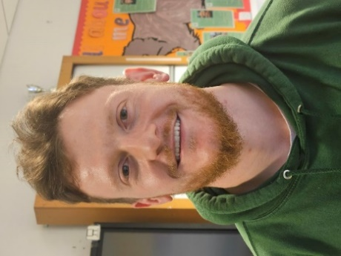
Ross Silver Jack Griffin
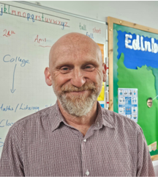
Susie Murphy John Dyble

Brrr Theatre Experience
In January four classes were able to take part in Brrr, an incredible interactive., immersive theatre experience! I’m delighted to say that we will be sending 4 more classes to the same experience during the Children’s Festival in June.

We hope to have an article published in the Currie & Balerno news!

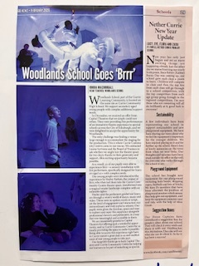

Cultural Visits and Opportunities
The whole school community enjoyed going to the panto at the Festival Theatre visit in January – huge planning and organisation goes into this and it’s great for our young people to be part of this annual event

Our Music Teacher, Raul, has secured free concerts for our senior pupils at Greyfriars Kirk
https://greyfriarskirk.com/events/?event-keyword=&event-cat=19&daterange=daterange&from-date=01%2F02%2F2026&to-date=30%2F06%2F2026

Our school choir recorded songs for the Head Teacher Inclusion Conference on Tuesday 3rd February. Our choir sang Mama Mia, Thank you, Bohemian Rhapsody and did some excellent signalong too!

Our school choir will be featuring at The Big Sing event on 18th June along with all schools from City of Edinburgh Council

Parent Coffee Mornings
Thank you to everyone for attending our last coffee morning on the 30th January which gave some useful information regarding Guardianship. It was fantastic to get such a large turnout and we hope those who attended found it helpful.

The parent council are keen to continue to grow and strengthen the community of Woodlands parents in further coffee mornings where we can share experiences and provide support to each other for the many processes we have to navigate to support our children. Please get in touch and let us know if there are particular areas you would like covered.
Email: parent_council_woodlands_school@yahoo.com

We are always happy to hear from you. Hope to see you at the next coffee morning on Thursday 26th February, 10am and the guest speaker is Heather Robertson our Speech and Language Therapist

Happy half term!
Emily Johnston Woodlands Parent Council

Currie High Demolition
We have been meeting with Keir Construction about the next stage of the Currie High demolition. From Easter to the Summer holidays our current carpark and drop off will be out of bounds so we are trying to come up with a safe alternative for our young people. We will do our best to reduce any disruption during the final term of the session.

New Pupils
We will be welcoming two new pupils into Woodlands after the February break. Our new S4 will be joining Deer Class and our new S1 pupil will be joining the Foxes!

Fundraising Events
This session we have had great success with fundraising - The Parent-Staff event was a huge success and raised around £1,800 and Christmas Fair also did very well.

We are in the process of planning another parent- staff social event for September so I hope to confirm a date for this soon!

Assembly Dates:

Friday 27th February Otters – Mr Davidson

Friday 6th March Wolves – Mr Jack

Friday 13th March Ospreys – Mr Griffin

Friday 20th March Foxes – Mr Silver

Friday 27th March Puffins – Mr Matthews

Thursday 2nd April Easter Disco – feel free to wear party clothes for the day!

School closes 3.55pm on Thursday 2nd April and reopens on Tuesday 21st April 9am for the Easter break

Please remember that our Parent Consultations will be taking place on Thursday 19th March from 4:30pm

Have a lovely half term break!

Rhoda


