Minutes of the Parent Council of Woodlands School Edinburgh held on Thursday 20 August 2026 in school
- Participants
- Gaynor Boe (Chair)
- Rhoda MacDougall (Head Teacher)
- Sinéad Reynolds (Vice Chair)
- Emily Johnston (Secretary)
- Simba Doka (Treasurer)
- Khalida Hussain
- Michelle Martin (via Teams)
Apologies received from Caroline Reid
- Minutes from previous PC Meeting
These were approved as a true and complete record, with no comments or objections.
- Treasurer’s report
Since the last meeting, a total of £1,819.80 has been received as funds from the sponsored walk (some in cash and mainly through the Just Giving website). In addition, £130 has been paid out for thank you gifts for staff and a parent of one of the leavers who has made significant contributions to the PC. The balance is currently £5,745.71.
- Headteacher’s report
See Appendix I
- Teachers/Principal Teacher/PSAs/Other class pupils for the
new academic year to be communicated to parents
Information will be sent out this week regarding teachers and PTs. Rhoda explained that it is not possible to share information about other class pupils yet as not all parents/carers have agreed to this. Another reminder has been sent to parents/carers.

- Transport update
There was a significant improvement this year in parents/carers receiving information about transport much earlier than in previous years, but there are still issues around last minute arrangements to meet drivers and assistants, causing unnecessary anxiety. There are also ongoing issues for some parents/carers with the transport assigned to them. The Council transport team has advised contacting them directly – Raymond Fleming (raymond.fleming@edinburgh.gov.uk) and Catrina Banks (catrina.banks@edinburgh.gov.uk).
- Scottish government consultation - breakfast clubs

The Government is eager to see breakfast clubs in all Scottish schools, including special schools. There are issues for our parents/carers around transport and the level of support required for our young people. Gaynor and Sinéad will attend the call on 20th August with representatives from the other Edinburgh special schools and report back.

- Coffee morning - dates/speakers tbc

Parent coffee mornings will be held on 24th September and 29th October in school. The September meet up will be an informal session just for parents/carers to get to know each other and discuss topics they’d like to hear more about. Caroline to get back to her contact at EDAN Hub to see if the October date is suitable.

- Parent/Staff social evening - final arrangements

Ceri, (one of our parents), Stacie and Pam (PSWs) have been working hard fundraising and organising for the event. The Parent Council has paid for the cost of the venue and the DJ and will organise snacks for the night. Regular reminders are being sent out by school highlighting that friends and family are also welcome to come along, but it's not possible for young people to attend. 28 tickets have been sold to date. Gaynor will post reminder messages on the parent WhatsApp channel and on the Facebook page.

10. AOCB
Gaynor raised that it is difficult to get past the queue for taxis at drop off/pick up now that there is only one lane. Rhoda offered to see if there is a way round this – literally!

Spifox, Wooden Spoon, Children in Need and Cash for Kids were identified as generous funders who may be able to provide funding for equipment and/or facilities, such as the sensory room and soft play, both of which need to be refurbished.

The Christmas Fair will take place on Friday 11th December. A planning meeting will be held on Thursday 17th September at 10am in school.

11. Date and time of next meeting
The next PC meeting will be on 5th November at 10.30am after the FOW meeting.

Appendix I HT report
Head Teacher’s Report
Parent Council
20th August 2026

Staffing Updates
- Eoghann Douglas has been appointed full time Acting PT until November 2028.
- We will be recruiting a new Pupil Support Officer role at Woodlands. Part of this role will be to support our parents and carers
- PSW – we will be doing regular interviews across the session to ensure we have sufficient staffing across all classes

Building Works and Improvements
- School car park reopened 12th Aug – still some fencing and planting to be completed.
- New toilets opened downstairs. Increased space for young people.

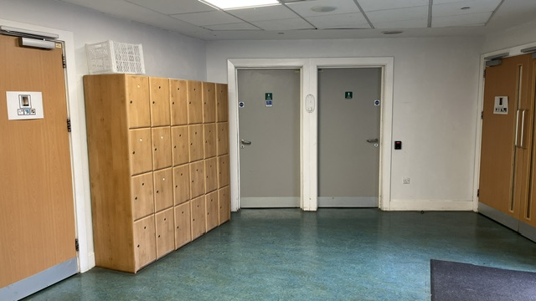

- Work will take place in the October holidays to replace the bridge from the car park to our reception area.
- Secure swipe access will be fitted to the South Playground doors to improve ease of access for staff and young people.
- Independent Living Skills room has now been furnished and is in use for all classes across the school. This space will allow more opportunities for our young people to practice skills for life.
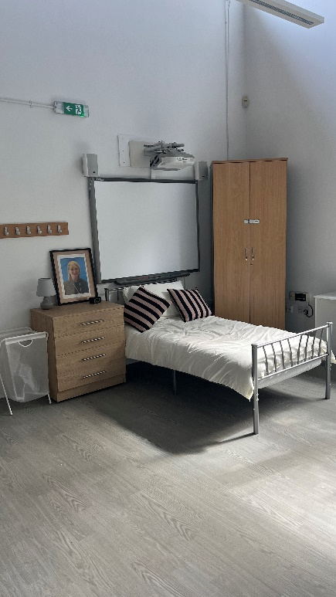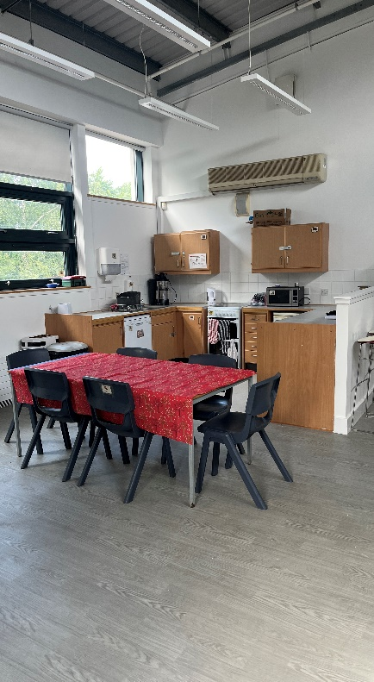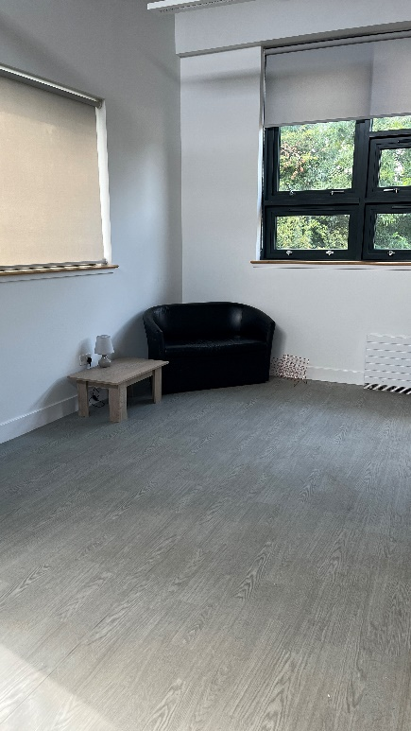

Rebound Therapy
- With thanks to Friends of Woodlands, we secured funds to hire transport for a group of young people to attend Rebound Therapy once a week at Oaklands School. We hope to start the sessions on Friday 28th August and Hares Class will be the first group to attend.

School Leavers June 2026
- We had lots of lovely celebrations for our S6 learners leaving Woodlands at the end of last session.
- Prom 2027 will take place on 4th June 2027 from 7pm at Slateford Bowling Club.

School Choir
- Our choir have secured a place at the Edinburgh Fringe Festival in August. Our young people will be doing a Signalong concert on a stage on the Royal Mile on 28th August at 11.30am.

Fundraising Events
- Parent-staff event on 4th September at Slateford Bowling Club 7pm, tickets £5.
- Some food will be provided by a local café, PC to provide nibbles.
- Raffle, quiz, and auction currently being organised.

Parent Workshops and Coffee Mornings
- Dates for this school session and speakers to be agreed

